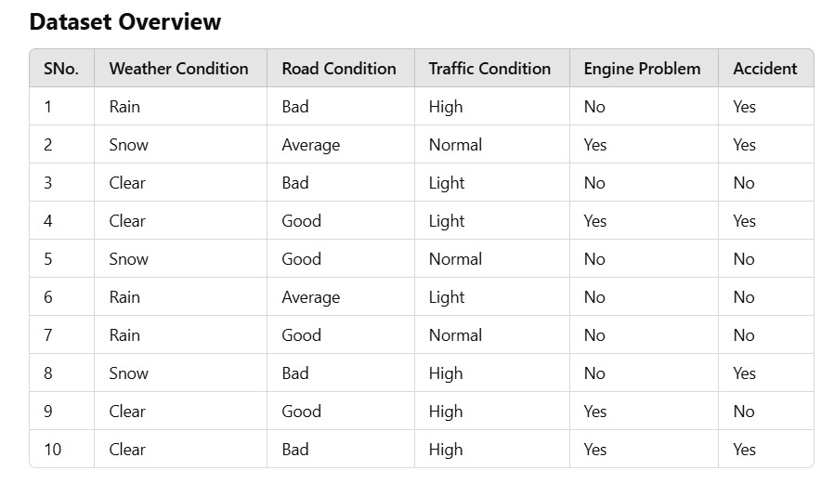

Student Exercises
- Calculate Entropy and Information Gain:
  - Compute the Information Gain for each attribute in the dataset.
  - Determine the root of the decision tree.
- Calculate Gini Impurity:
  - Perform the same split analysis using Gini Impurity.
  - Compare the splits obtained with Entropy and Gini.
- Construct the Tree:
  - Build the decision tree manually based on your calculations.

ANSWERS
1) Entropy (dataset):
1.0
Information Gain:
- Weather Condition: 0.049
- Road Condition: 0.044
- Traffic Condition: 0.364
- Engine Problem: 0.125
Root of Decision Tree:
Traffic Condition

2) Gini Impurity (best split):
Traffic Condition (Gini = 0.293)
Comparison:
Same split for Entropy and Gini

3) Final Decision Tree:
- Traffic = Light → No Accident
- Traffic = Normal → No Accident
- Traffic = High → Accident = Yes

